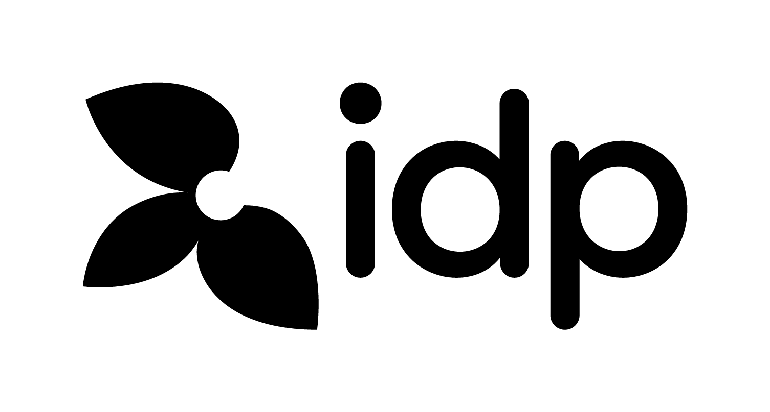
LETTER OF ACCEPTANCE
Admission Day May 2022

Interpreter Name: Le Vinh Tuong An

Address: 342 Ông Ích Khiêm, Phường Vĩnh Trung, Quận Thanh Khê, TP Đà Nẵng

Account number: 56010001323702

Bank: BIDV chi nhánh Hải Vân

Mobile: 0765758948

Email: levinhtuongan297@gmail.com

ID/Passport Number: 048199000321

Personal Tax Code:

Thank you very much for your interest in working with us in “Admission Day May 2022” as an interpreter on Thursday, 05.05.2021 at Novotel Da Nang, 36 Bach Dang Str., Da Nang City.

We would like to advise you that your wage for 4-hour working with us as an interpreter of the above event will be VND 500,000.

Your duty is as follow:
- Read institution’s website in advance by visiting their websites to understand the overview about the institution, their courses and services.
- Interpret for institution representatives at exhibition booths.
- Upon request from institutional representatives, answer basic questions on “Admission Day May 2022” to booth visitors. For specific enquiries, please refer students/ parents to IDP staff at counseling desk.
- Record visitors’ full information (Name, Date of Birth, Phone, Email, interested level of study, interested major of study and other notes into institution’s CVENT account / follow up form and return it to IDP staff after event (19:00) (Ms. Ha Phan).
- From time to time assist institution representatives with photocopies and material preparation/packing.

Please note that if your monthly salary exceeds VND 2,000,000, personal income tax will be charged to your salary.

If you agree with this offer, please sign and return this letter to IDP as your official acceptance.

Yours sincerely, Interpreter’s Signature

___________________
TRAN NGOC TRAM Name: Le Vinh Tuong An
Da Nang Office Manager
IDP Education (Vietnam)

